   

Sentiment analysis AI system

A Project Report

submitted in partial fulfillment of the requirements of

AIML Fundamentals with Cloud Computing and Gen AI

by

**S.Ranjith** [**selvammanjula02@gmail.com**](selvammanjula02%40gmail.com)

**0EE86FF78C8C13B869D4565531EB2952 (au921021114028)**

**921021114028**

**Nadar Saraswathi College of Engineering and Technology, Theni**

Under the Guidance of

# P.Raja, Master Trainer

   

# ACKNOWLEDGEMENT

We would like to take this opportunity to express our deep sense of gratitude to all individuals who helped us directly or indirectly during this thesis work.

Firstly, we would like to thank my supervisor, Raja EDUNET, for being a great mentor and the best adviser I could ever have. His advice, encouragement and critics are source of innovative ideas, inspiration and causes behind the successful completion of this dissertation. The confidence shown on me by him was the biggest source of inspiration for me. It has been a privilege working with himfrom 3 months. He was very detailed in his explanation and was thorough with the subject. His step by step instruction was very clear. The way he carried the classes were really intriguing

Next, I would like to thank the naan mudhalvan organization for providing us with this wonderful opportunity. I’m really grateful to have access to an opportunity to learn new things. The naan mudhalvan team has provided us with many opportunities to become a better individual and acquire new knowledge each semester. This semester was no different. I enjoyed each and every course that was given to us. I thank the team for their efforts.

Finally, I would like to thank my college, Nadar Saraswathi College of Engineering and Technology, Theni, for planning our classes accordingly. I also thank all the staff in-charges, who played an active role in making our journey as smooth as possible. I would also like to sincerely thank my colleagues for providing a safe environment where we can discuss our doubts and grow together.

Thank you all for providing me with such an amazing opportunity.

   

# ABSTRACT

Sentiment analysis, also known as opinion mining, is a natural language processing (NLP) technique that identifies and extracts subjective information from text. This approach focuses on determining the emotional tone of the content, categorizing it as positive, negative, or neutral. It has significant applications in fields like marketing, customer service, finance, and social media monitoring. By analyzing user-generated content, sentiment analysis helps businesses gauge public opinion, identify trends, and make data-driven decisions. Techniques range from simple lexicon-based methods to complex machine learning and deep learning models. Lexicon-based methods use predefined dictionaries of words associated with specific emotions, while machine learning approaches train models on annotated datasets, enabling the system to recognize patterns and classify sentiments automatically. Deep learning, particularly through models like recurrent neural networks (RNNs) and transformers, has advanced sentiment analysis, offering higher accuracy by capturing context and nuances in language. Although promising, challenges remain, such as handling sarcasm, context-dependency, and multilingual text.

   

# TABLE OF CONTENTS

Abstract 3

List of Figures 8

**Chapter 1. Introduction** 9

* 1. Problem Statement 9
  2. Motivation 9
  3. Objectives 9
  4. Scope of the Project 10
     1. Emotion Detection 10
     2. Aspect-Based Sentiment Analysis 10
     3. Opinion Mining 10
     4. Multilingual Sentiment Analysis 10
     5. Social Media Sentiment 10
     6. Limitations of Sentiment Analysis 10
        1. Context Dependency 10
        2. Ambiguity in Sentiment Expression 10
        3. Subtle Sentiments 11
        4. Domain-Specific Challenges 11
        5. Lack of Deep Understanding 11

**Chapter 2.Literature Survey** 12

* 1. Review relevant literature or previous work in this domain 12
     1. Early Foundations and Rule-Based Approaches 12
     2. Machine Learning-Based Approaches 12
     3. Deep Learning Approaches 12

   

* + 1. Multilingual and Cross-Domain Sentiment Analysis 12
    2. Pre-trained Transformer Models 13
  1. Mention any existing models, techniques, or methodologies related to the problem 13
     1. Bag of Words (BoW) Model 13
     2. TF-IDF (Term Frequency-Inverse Document Frequency) 13
     3. Lexicon-Based Methods 13
     4. Machine Learning-Based Techniques 14
     5. Deep Learning Models 14
  2. Highlight the gaps or limitations in existing solutions and how your project will address them 14
     1. Contextual Understanding of Language 14
     2. Handling Mixed Sentiment 14
     3. Domain-Specific Vocabulary 15
     4. Dealing with Low-Resource Languages 15
     5. Bias in Sentiment Analysis Models 15

**Chapter 3. Proposed Methodology** 16

* 1. System Design 16
     1. Registration 16
        1. Data Preprocessing and Standardization 16
        2. Domain-Specific Sentiment Mapping 16
     2. Recognition 16
        1. Identifying Sentiment Indicators 17
        2. Emotion Recognition and Classification 17
        3. Entity Recognition and Contextual Sentiment Analysis 17
        4. Aspect-Based Sentiment Recognition 17

   

* 1. Modules Used 17
     1. Text Preprocessing 17
     2. Feature Extraction 18
     3. Sentiment Classification 18
        1. Lexicon-based Approaches 18
        2. Machine Learning Models 18
        3. Deep Learning Models 19
     4. Face Detection 19
        1. Face Detection 19
        2. Facial Expression Recognition 19
        3. Enhancing Text-Based Sentiment with Visual Cues 20
        4. Improving Customer Experience 20
        5. Real-Time Sentiment Monitoring 20
  2. Data Flow Diagram 21
  3. Advantages 22
     1. Real-Time Feedback and Monitoring 22
     2. Enhanced Customer Insights 22
     3. Improved Decision-Making 22
     4. Competitive Analysis 22
     5. Brand Monitoring and Reputation Management 22
     6. Market Research and Trend Analysis 22
  4. Requirement Specification 23
     1. Hardware Requirements 23
     2. Software Requirements 23

Chapter 4. Implementation and Results 24

   

* 1. Results of Face Detection 24
  2. Results of Face Recognition 25
  3. Result Of Concentration Analysis 27

**Chapter 5. Discussion and Conclusion** 29

* 1. GitHub Link of the Project 29
  2. Video Recording of Project Demonstration 29
  3. Limitations 29
     1. Contextual Understanding and Nuance 29
     2. Sarcasm and Irony 29
     3. Ambiguity and Subjectivity 29
     4. Limited Handling of Mixed Sentiments 30
     5. Cultural and Linguistic Variability 30
  4. Future Work 30
     1. Improved Contextual Understanding 30
     2. Sarcasm and Irony Detection 30
     3. Aspect-Based Sentiment Analysis (ABSA) 31
     4. Cross-Domain and Transfer Learning 31
     5. Multilingual and Cross-Cultural Sentiment Analysis 31
     6. Emotion Recognition and Sentiment Granularity 31
  5. Conclusion 32

**References** 33

   

# LIST OF FIGURES

|  |  |  |
| --- | --- | --- |
| **Figure No** | **Name of List of Figure** | **Page No.** |
| **Figure 1** | **Figure 4.1.1 Data Training** | **21** |
| **Figure 2** | **Figure 4.1.2 User interface** | **21** |
| **Figure 3** | **Figure 4.1.3 User Interface Result** | **22** |
| **Figure 4** | **Figure 4.2.1 Face Recognition** | **22** |
| **Figure 5** | **Figure 4.2.2 Data Processing** | **23** |
| **Figure 6** | **Figure 4.2.3 Data Processing Result** | **23** |
| **Figure 7** | **Figure 4.3.1 Positive and Negative Sentiment Analysis** | **24** |
| **Figure 8** | **Figure 4.3.2 Sentiment Analysis** | **24** |
| **Figure 9** | **Figure 4.3.3 Create bag of words** | **25** |
| **Figure 10** | **Figure 4.3.4 Biderectional LSTM Using NN** | **25** |

   

# CHAPTER 1

**Introduction**

## Problem Statement:

To develop an automated system capable of accurately identifying, extracting, and classifying the emotional tone (positive, negative, neutral, or other nuanced sentiments) of user-generated text data. This system should handle large volumes of data efficiently, processing content from various sources such as social media, customer reviews, and surveys. It should address challenges such as contextual understanding, handling of ambiguous or sarcastic language, and processing text in multiple languages. The objective is to enable businesses and organizations to gain insights into public opinion, track brand reputation, and improve customer experience by making informed decisions based on real-time sentiment data.

## Motivation:

The motivation for developing Sentiment Analysis systems lies in the growing importance of understanding public opinion and emotional responses in a world flooded with user-generated content. With the rise of social media, online reviews, and forums, people increasingly share their views, preferences, and feedback online. For businesses, governments, and organizations, this presents an invaluable source of insights into customer satisfaction, brand perception, and market trends.

By automating sentiment analysis, companies can better understand customer emotions, predict market shifts, and enhance product development by responding to real-time feedback. Sentiment analysis can also assist in managing crises, detecting potential issues, and improving customer service, leading to higher user engagement and loyalty. Additionally, in fields like politics and public health, sentiment analysis aids in tracking public opinion, enabling more responsive policies and communications.

## Objective:

The objectives of a project in Sentiment Analysis are to develop a system capable of identifying, extracting, and interpreting subjective information from text data to determine the underlying sentiment expressed. This system aims to classify emotions, opinions, or attitudes—whether positive, negative, or neutral—toward particular subjects, products, services, or events. By analyzing large volumes of text data from sources like social media, customer reviews, or survey responses, the project seeks to understand trends in public sentiment and provide actionable insights to businesses, researchers, and decision-makers. Furthermore, the project

   

may aim to enhance the accuracy and efficiency of sentiment classification through machine learning algorithms, natural language processing (NLP) techniques, and possibly deep learning models, addressing challenges such as sarcasm, context sensitivity, and varying linguistic styles. Ultimately, the goal is to create a robust, scalable tool for real-time sentiment monitoring, providing valuable information for strategic decision-making and improving user experience.

## .Scope of the Project:

## Emotion Detection:

Identifying specific emotions expressed within a text, such as joy, sadness, anger, surprise, etc. Commonly used in customer feedback, social media posts, reviews, and surveys to gauge public opinion.

## Aspect-Based Sentiment Analysis:

Identifying sentiment with respect to specific aspects or features of a product, service, or topic. For instance, in a restaurant review, sentiment analysis might separately evaluate the "food quality" versus "service quality."

## Opinion Mining:

Extracting subjective information from text, such as identifying whether the text expresses a favorable or unfavorable opinion about a particular entity or event.

## Multilingual Sentiment Analysis:

Analyzing sentiments in texts written in multiple languages, though this requires tailored models for different languages.

## Social Media Sentiment:

Analyzing sentiments in real-time from social media platforms (e.g., Twitter, Facebook, Reddit) to gauge public sentiment about events, brands, or products.

## Limitations of Sentiment Analysis:

* + - 1. **Context Dependency**:

Sentiment analysis can struggle with understanding context or nuances in language. For example, sarcasm, irony, or humor can lead to incorrect sentiment classification (e.g., "Great, another delay" could be interpreted as positive when it is actually negative).

## Ambiguity in Sentiment Expression:

Sentiment analysis may struggle with words or phrases that have multiple meanings depending on context. For example, the word "sick" could refer to something "awesome" in slang or indicate an actual health issue, leading to confusion.

   

## Subtle Sentiments:

Sometimes, sentiments are expressed in a subtle or indirect way, making it difficult for a model to correctly detect the sentiment. Texts like "I don't hate it" or "It's not bad" are ambiguous and harder for models to interpret.

## Domain-Specific Challenges:

Sentiment analysis models trained on general data may not perform well in specialized domains, such as medical, legal, or technical texts. A sentiment expressed in one domain may require specific context or expertise to understand.

## Lack of Deep Understanding:

Sentiment analysis typically works at the surface level of text. It doesn't always understand underlying emotions or cognitive processes that may be conveyed indirectly.

   

# CHAPTER 2

**Literature Survey**

## Review relevant literature or previous work in this domain:

## Early Foundations and Rule-Based Approaches:

In the early stages of sentiment analysis, researchers employed *rule-based systems* for sentiment classification, relying on manually crafted dictionaries and predefined rules to detect sentiment in text. One of the seminal works in sentiment analysis is the development of the *Opinion Finder* by *Wiebe et al. (2005)****,*** which was one of the first systems to use a lexicon-based approach for extracting opinions from text. The *Subjectivity Lexicon* developed by *Pang and Lee (2008)*, which contained a list of subjective words, also served as an early foundation for sentiment analysis models. These early systems, while effective to a certain extent, were limited in their ability to capture context, sarcasm, and complex sentence structures.

## Machine Learning-Based Approaches:

As the field of machine learning progressed, researchers moved from rule-based systems to *supervised learning* models for sentiment analysis. *Pang and Lee (2002)* presented one of the most influential studies in this area, using machine learning methods to classify movie reviews as positive or negative. They applied *Naive Bayes, Support Vector Machines (SVMs***)**, and *Maximum Entropy classifiers* to analyze sentiment, and their work demonstrated that machine learning algorithms could outperform rule-based systems in terms of accuracy and scalability.

## Deep Learning Approaches:

The advent of deep learning techniques marked a new era in sentiment analysis. *Convolutional Neural Networks (CNNs)* and *Recurrent Neural Networks (RNNs)* were applied to sentiment classification tasks, allowing for more sophisticated representations of text that could capture intricate patterns in sentence structures. *Kim (2014)* introduced a *CNN model* for sentence-level sentiment analysis, which achieved state-of-the-art results on the *Stanford Sentiment Treebank (SST)* dataset.

## Multilingual and Cross-Domain Sentiment Analysis:

Sentiment analysis has expanded beyond English to include multilingual sentiment analysis. Researchers like *Xue et al. (2017)* explored how sentiment analysis models could be adapted for languages other than English, developing multilingual word embeddings that allow

   

models to generalize across languages. The development of *multilingual BERT (mBERT)* further supported these efforts by providing pre-trained models for 104 languages, enabling sentiment analysis in a wide variety of languages with minimal additional training data.

## Pre-trained Transformer Models:

With the rise of transformer-based architectures such as *BERT (Bidirectional Encoder Representations from Transformers) by Devlin et al. (2018)*, sentiment analysis saw a dramatic leap in performance. BERT's pre-trained models, which leverage massive amounts of unlabelled data, allow for *fine-tuning* on specific sentiment analysis tasks. BERT's bidirectional attention mechanism, which considers both left and right context simultaneously, has proven effective in understanding the nuances of language, including sarcasm, ambiguity, and context shifts. Subsequent variants of BERT, such as *RoBERTa (Liu et al., 2019)* and *DistilBERT (Sanh et al., 2019)****,*** further enhanced model efficiency and accuracy.

## Mention any existing models, techniques, or methodologies related to the problem:

## Bag of Words (BoW) Model:

This traditional technique converts text into a set of words or tokens, disregarding grammar and word order but maintaining the frequency of each word. In sentiment analysis, words associated with positive or negative sentiment are used to determine the overall sentiment of a sentence or paragraph.

## TF-IDF (Term Frequency-Inverse Document Frequency):

TF-IDF is an extension of BoW that emphasizes important words by calculating how relevant a word is within a specific document compared to its presence across multiple documents. TF-IDF helps in sentiment analysis by giving more weight to sentiment-heavy terms that occur frequently in specific contexts but not in general language.

## Lexicon-Based Methods:

Lexicon-based approaches rely on predefined sentiment lexicons, which are lists of words labeled with their sentiment (positive, negative, or neutral). Popular lexicons like AFINN, VADER (Valence Aware Dictionary and Sentiment Reasoner), and SentiWordNet assign sentiment scores to words or phrases. These methods are effective in simpler applications but often struggle with context or sarcasm.

   

## Machine Learning-Based Techniques:

Machine learning models, such as Naive Bayes, Support Vector Machines (SVM), and Logistic Regression, are widely used in sentiment analysis. These models are trained on labeled data to predict sentiment based on word patterns. They often perform better than lexicon-based methods, especially when trained on large datasets.

## Deep Learning Models:

Deep learning models, particularly Recurrent Neural Networks (RNNs), Long Short-Term Memory (LSTM) networks, and Convolutional Neural Networks (CNNs), have shown promising results in sentiment analysis. LSTM networks, for example, are capable of learning the context of a word based on previous words in a sentence, which is valuable for understanding complex sentiment patterns.

## Highlight the gaps or limitations in existing solutions and how your project will address them:

## Contextual Understanding of Language:

**Limitation**: Many sentiment analysis models struggle to capture context accurately. For instance, phrases with sarcasm, idioms, or slang can often be misinterpreted. Models sometimes rely heavily on keywords rather than the true context, leading to inaccurate sentiment scores.

**Proposed Solution**: To address this, my project would integrate a contextual language model, like BERT or GPT, fine-tuned specifically for sentiment analysis. This approach would enhance the model's ability to understand context, improving the handling of nuanced language.

## Handling Mixed Sentiment:

**Limitation**: In many texts, multiple sentiments are expressed. Current models often classify entire texts as either positive, negative, or neutral, ignoring mixed sentiments. This is especially relevant in reviews or discussions where both pros and cons are mentioned.

**Proposed Solution**: My project would employ a multi-label classification approach, allowing the model to assign multiple sentiment labels to a single text. Additionally, it would use sentence-level sentiment analysis to capture different sentiments in each part of the text.

   

## Domain-Specific Vocabulary:

**Limitation**: Many sentiment analysis models struggle with domain-specific language. For example, words that are positive in one industry (e.g., “hard” for “hard science”) may not be interpreted correctly in another context.

**Proposed Solution**: My project would incorporate domain adaptation techniques, including training on domain-specific corpora and using vocabulary tuning, so that the model accurately interprets terms in the specific industry or context.

## Dealing with Low-Resource Languages:

**Limitation**: While sentiment analysis for English and other widely spoken languages is relatively advanced, low-resource languages often lack robust sentiment analysis tools.

**Proposed Solution**: To address this, my project would incorporate transfer learning from high-resource languages to low-resource ones. By using a multi-lingual model and fine- tuning with available low-resource language datasets, we can improve the accuracy for these languages.

## Bias in Sentiment Analysis Models:

**Limitation**: Sentiment analysis models sometimes show bias, particularly around sensitive topics (like race, gender, or politics), as they may pick up and replicate biases in the training data.

**Proposed Solution**: My project would implement a bias mitigation step, which involves fine-tuning with a balanced and diverse dataset, regular monitoring of sentiment scores across different demographics, and using de-biasing algorithms to ensure a more balanced and fair model.

   

# CHAPTER 3

**Proposed Methodology**

## System Design:

A sentiment analysis system can be designed by combining multiple layers to achieve accurate, context-aware, and interpretable results. First, raw text data is pre-processed through tokenization, stemming, and removal of stop words to standardize the input. The core model, often a neural network like BERT or LSTM, is trained on labeled sentiment datasets to learn semantic relationships in text.

## Registration:

In sentiment analysis, "registration" typically refers to the process of aligning or matching different types of data to enhance the accuracy of sentiment classification. It often involves synchronizing textual data (like words or sentences) with their sentiment polarity (positive, negative, neutral) and intensity.

## Data Preprocessing and Standardization:

Ensuring text data is cleaned, tokenized, and transformed into a consistent format, making it ready for analysis. This includes removing special characters, stemming, and lowercasing words.

## Domain-Specific Sentiment Mapping:

In specialized fields, sentiments may be registered or mapped according to domain-specific lexicons. For instance, the word "cold" might have a negative connotation in customer service but a positive one in sports.

## 3.1.1.2 Alignment of Multimodal Data:

In cases where sentiment analysis involves audio or visual data (e.g., analyzing customer support videos), registration might involve aligning text transcripts with corresponding emotional cues from voice or facial expressions.

## Recognition:

In sentiment analysis, "recognition" generally refers to the process of identifying and classifying the sentiment expressed in a piece of text (or other data types, like audio or

   

images) as positive, negative, or neutral. Recognition is key in determining the sentiment "polarity"

## Identifying Sentiment Indicators:

Recognition involves detecting specific words, phrases, or expressions that suggest an emotion or opinion. For example, words like "happy," "terrible," and "excited" each have a sentiment that can be recognized as positive or negative.

## Emotion Recognition and Classification:

Beyond simply positive or negative, some advanced sentiment analysis systems can classify text by specific emotions, like joy, sadness, anger, or surprise. This approach often requires training a model on datasets labeled with emotional categories.

## Entity Recognition and Contextual Sentiment Analysis:

In many cases, the sentiment isn't directed at the entire text but at specific entities (e.g., a product or service). Named Entity Recognition (NER) is combined with sentiment analysis to identify not only the sentiment but also the subject of the sentiment.

## Aspect-Based Sentiment Recognition:

In more nuanced analysis, systems recognize different aspects or features discussed within the same text. For example, a restaurant review might express a positive sentiment about the food but a negative one about the service. Recognition here helps in isolating and analyzing sentiments on specific aspects.

## Modules Used:

## Text Preprocessing:

**Tokenization:** Breaking the text into words or tokens. This helps in analyzing individual components of the text.

**Stopword Removal:** Removing common words (e.g., "the," "and," "is") that don't carry significant meaning in sentiment analysis.

**Lowercasing:** Converting all words to lowercase to maintain uniformity and avoid redundancy.

**Stemming and Lemmatization:** Reducing words to their root form (e.g., "running" becomes "run"), which helps in grouping similar words together.

   

**Special Character Removal:** Cleaning the text by removing irrelevant characters like punctuation, numbers, etc.

## Feature Extraction

**Bag of Words (BoW):** Represents the text as a collection of words without considering grammar or word order. This approach can be used to transform text into a feature vector for machine learning.

**TF-IDF (Term Frequency-Inverse Document Frequency):** Weighs words according to their importance in a document relative to a collection of documents. Words that are unique to a document get higher weights.

**Word Embeddings (e.g., Word2Vec, GloVe):** These models represent words in vector space, capturing semantic meaning and relationships between words based on context. They help in better understanding the sentiment and nuances in text.

**N-grams:** Grouping sequences of 'n' words together to capture local context (e.g., bigrams or trigrams), improving sentiment analysis accuracy.

## Sentiment Classification

## Lexicon-based Approaches:

**Sentiment Lexicons (e.g., AFINN, SentiWordNet):** These are predefined sets of words with associated sentiment scores (positive, negative, or neutral). The sentiment of a document can be determined by aggregating the scores of the words it contains.

**VADER (Valence Aware Dictionary and sEntiment Reasoner):** A lexicon specifically designed for social media text (tweets, reviews), which assigns sentiment scores based on words and context.

## Machine Learning Models:

**Naive Bayes Classifier:** A probabilistic classifier that is widely used in sentiment analysis. It assumes independence between features (words) and classifies text based on conditional probability.

**Support Vector Machine (SVM):** A supervised machine learning model that works well for classification tasks, including sentiment analysis, by finding the optimal hyperplane that divides sentiment classes.

   

**Logistic Regression:** A classification algorithm used to predict binary sentiment labels (positive/negative).

**Decision Trees and Random Forests:** These can be used for sentiment classification by creating decision rules based on features extracted from the text.

## Deep Learning Models:

**Convolutional Neural Networks (CNN):** Although CNNs are mostly associated with image recognition, they can also be used for sentiment analysis by treating text as a 1D sequence.

**Recurrent Neural Networks (RNN):** These models are used for sequential data and are especially effective when handling sentiment analysis tasks that require understanding the context and order of words.

**Long Short-Term Memory (LSTM) Networks:** A type of RNN that is good for handling long-range dependencies in text, helping the model understand context over long passages.

**Transformers (e.g., BERT, GPT):** Pretrained models like BERT (Bidirectional Encoder Representations from Transformers) capture deep contextual relationships in text and have set new benchmarks for sentiment analysis tasks.

## Face Detection:

## Face Detection:

**Objective:** Identify and locate faces within an image or video frame.

**Techniques:** Models like Haar Cascades, HOG (Histogram of Oriented Gradients), and deep learning-based methods such as CNNs and MobileNet are commonly used for detecting faces in real-time or static images.

**Libraries and Tools:** OpenCV, Dlib, and deep learning frameworks like TensorFlow and PyTorch have face detection models to identify face regions efficiently.

## Facial Expression Recognition:

**Objective:** Once a face is detected, recognize and classify facial expressions as specific emotions (e.g., happy, sad, angry, surprised, etc.).

   

## Techniques:

**Emotion Recognition Models:** After detection, models like CNNs and RNNs, especially designed to classify facial expressions, can be applied to analyze facial emotions.

**Action Units (AUs):** Models trained to detect combinations of facial muscle movements, known as Action Units (AU), help in recognizing complex expressions.

**Pretrained Models and APIs:** Pretrained models like FER (Facial Expression Recognition) models, and services like Microsoft Azure's Face API and Google’s Vision API, can provide out-of-the-box facial emotion recognition.

## Enhancing Text-Based Sentiment with Visual Cues:

Text can sometimes be ambiguous, especially when sarcasm, irony, or subtle emotional undertones are present. Facial expressions offer **non-verbal cues** that can confirm or clarify the sentiment expressed in text.

For example, a user may write “I just love when my flight is delayed…” sarcastically. While text-based sentiment analysis might misclassify this as positive, the addition of facial expression data (e.g., an annoyed look) helps accurately identify the negative sentiment.

## Improving Customer Experience:

In customer service interactions (such as virtual chat, calls, or video support), face detection coupled with sentiment analysis allows companies to assess customer satisfaction in real time.

Detecting customer emotions through facial expressions can alert support agents to frustration or satisfaction, prompting immediate responses and improving service quality.

## Real-Time Sentiment Monitoring:

Real-time sentiment analysis using face detection is valuable for applications like live event monitoring, where facial expressions of participants (in focus groups, classrooms, conferences) can be tracked to gauge overall sentiment or engagement levels.

This approach can help event organizers, educators, or marketers make on-the-spot adjustments based on real-time feedback from their audience.

   

## Data Flow Diagram:

A Data Flow Diagram (DFD) is a graphical representation of the "flow" of data through an information system, modeling its process aspects. A DFD is often used as a preliminary step to create an overview of the system, which can later be elaborated. DFDs can also be used for the visualization of data processing (structured design).



Negat ive Polari ty

Special Character and Symbol Eliminati

Slag Words and URL Remover

Neu tral Pola rity

Posit ive Polar ity

Visualizatio

Data Classification

Data Labeling

Data Preprocessing

Data Extraction

Set Data

Data Extract or

Normali zation

Storage Collector

Get Data Which is Analyzed by Textblob

Preprocessing Data

Access Data

Start

Google

Play

Data

Gathering

Requirement

Data Storage

API



   

## Advantages:

Sentiment analysis offers numerous advantages across various fields, enabling organizations and individuals to gauge opinions, emotions, and overall attitudes in textual data.

## Real-Time Feedback and Monitoring:

Sentiment analysis tools can monitor customer feedback, social media, and reviews in real time. This allows businesses to respond to customer opinions, handle crises, or address negative feedback promptly.

## Enhanced Customer Insights:

By analyzing customer sentiment, companies gain a deeper understanding of their customers’ feelings, preferences, and pain points. This insight can improve customer service, product offerings, and personalized marketing.

## Improved Decision-Making:

Organizations can make data-driven decisions based on sentiment data. For example, they might choose to improve a product based on negative feedback or expand features that customers appreciate.

## Competitive Analysis:

Sentiment analysis allows companies to monitor competitors' public perception, especially on social media. By comparing sentiments related to different brands, companies can identify areas where they have a competitive edge or need improvement.

## Brand Monitoring and Reputation Management:

Sentiment analysis helps organizations monitor brand perception and reputation. By detecting spikes in negative sentiment, companies can manage potential PR issues and respond appropriately to maintain a positive brand image.

## Market Research and Trend Analysis:

Sentiment analysis can reveal emerging trends, consumer preferences, and shifts in opinion over time. This information is valuable for market research, product development, and strategic planning.

   

## Requirement Specification:

## Hardware Requirements:

The hardware requirements for sentiment analysis depend on the scale and complexity of the tasks being performed. For basic sentiment analysis tasks, a standard desktop or laptop with a multi-core processor (e.g., Intel i5 or higher), 8GB of RAM, and sufficient storage (at least 100GB) can be adequate. However, for larger datasets, real-time analysis, or deep learning models, more powerful hardware is necessary. This includes higher-end processors (e.g., Intel i7/i9 or AMD Ryzen), at least 16GB of RAM, and dedicated GPUs (e.g., NVIDIA GTX/RTX) to accelerate deep learning computations. Additionally, cloud-based solutions with scalable resources may be required for processing large volumes of data or for production-level deployment.

## Software Requirements:

The software requirements for sentiment analysis include tools for data collection, such as APIs for gathering text from social media, reviews, and surveys. The system must support text preprocessing techniques like tokenization, stopword removal, and stemming to clean the data. Machine learning or deep learning models, such as Naive Bayes, SVM, or neural networks, are needed to classify the sentiment of the text into categories like positive, negative, or neutral. Libraries like scikit-learn, TensorFlow, or PyTorch may be used for model development, and NLP tools like NLTK or spaCy for preprocessing. The system should also include visualization tools for presenting sentiment trends and performance metrics. Scalability, real-time processing, and data security are also important considerations.

   

# CHAPTER 4

**Implementation and Result**

**4.1.Results of Face Detection:**

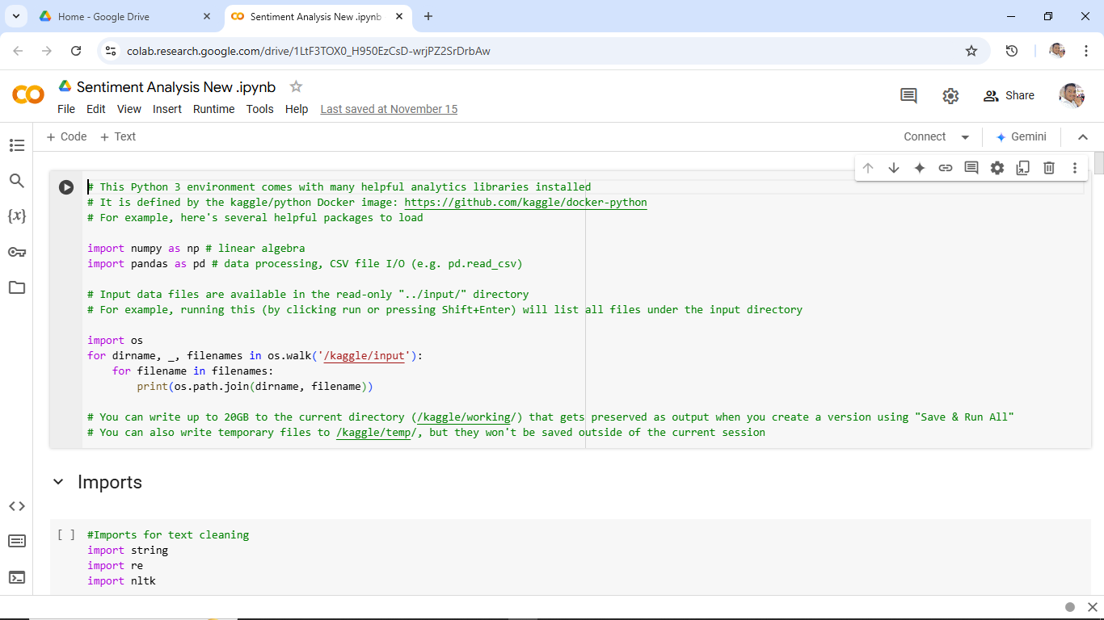

**Figure 4.1.1 Data Training**

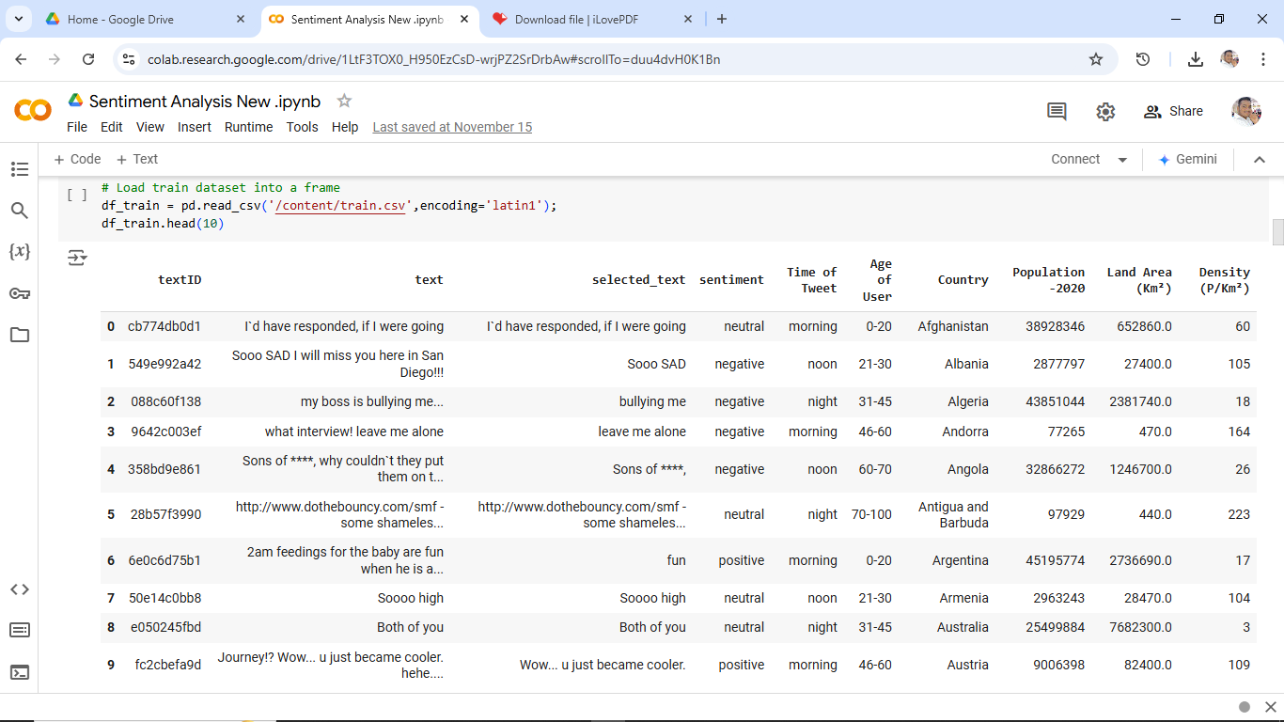

**Figure 4.1.2 User interface**

   

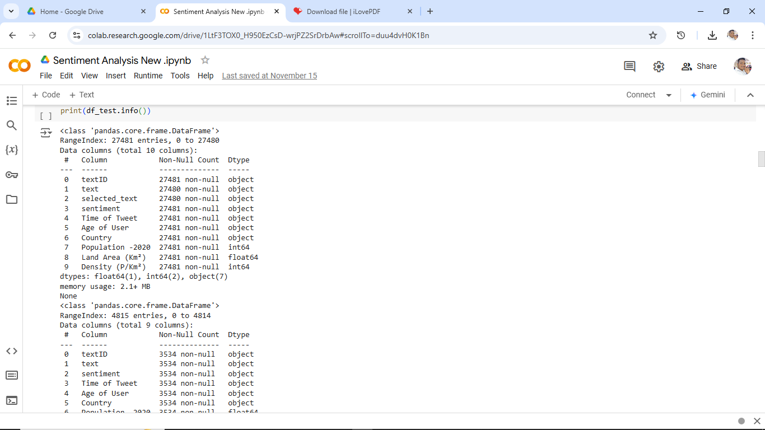

**Figure 4.1.3 User Interface Result**

## 4.2.Results of Face Recognition:

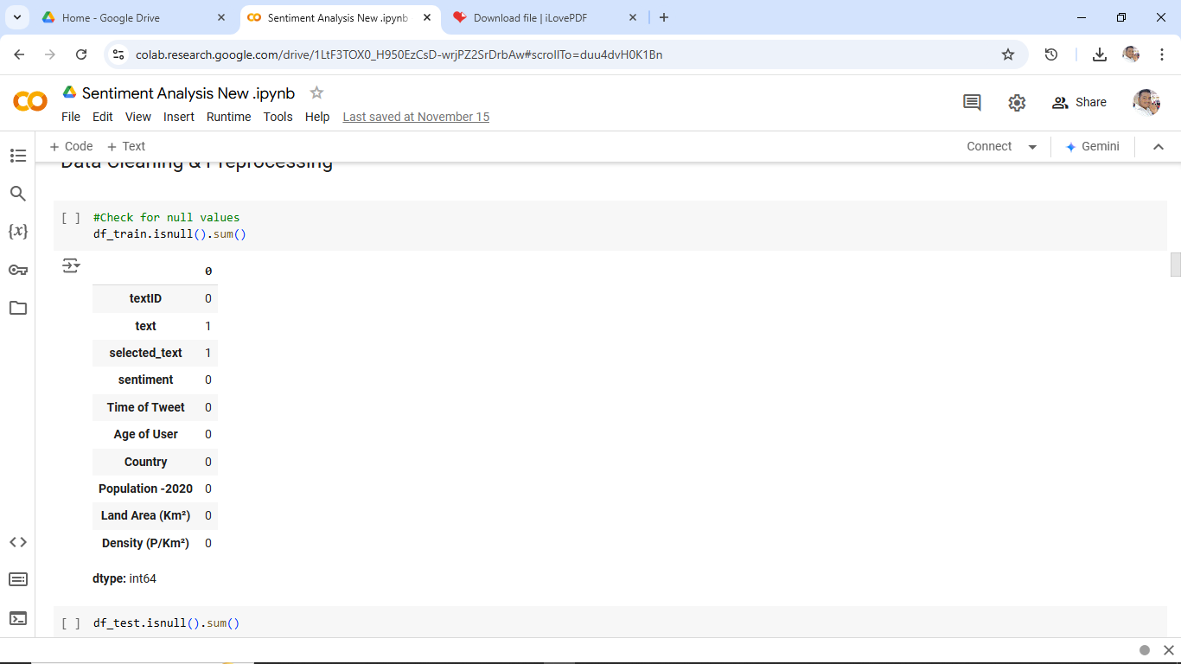

**Figure 4.2.1 Face Recognition**

   

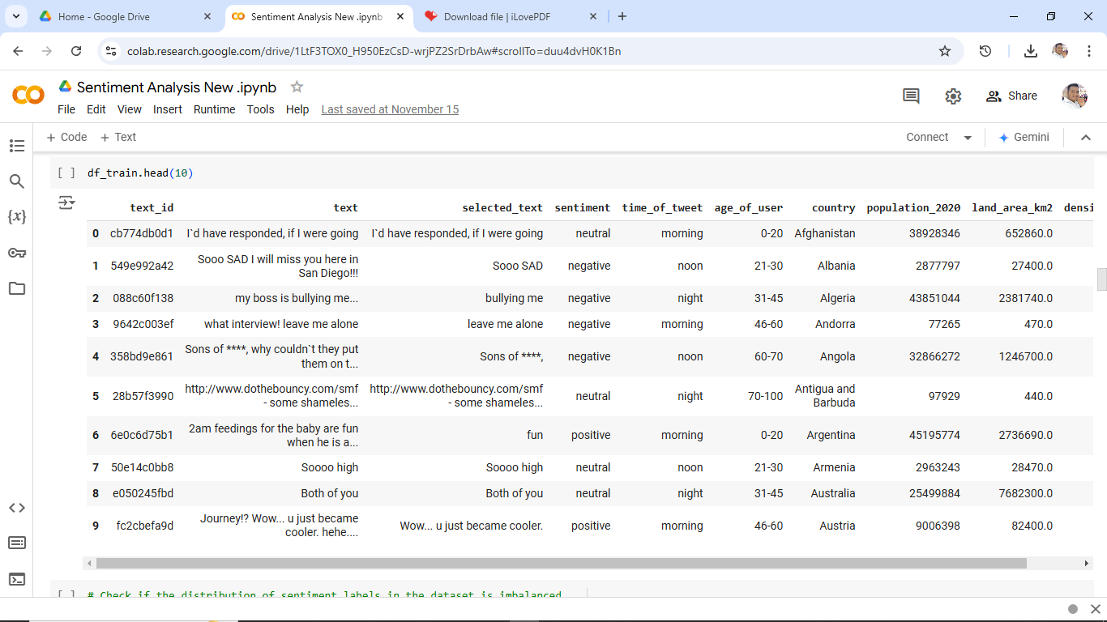

## Figure 4.2.2 Data Processing

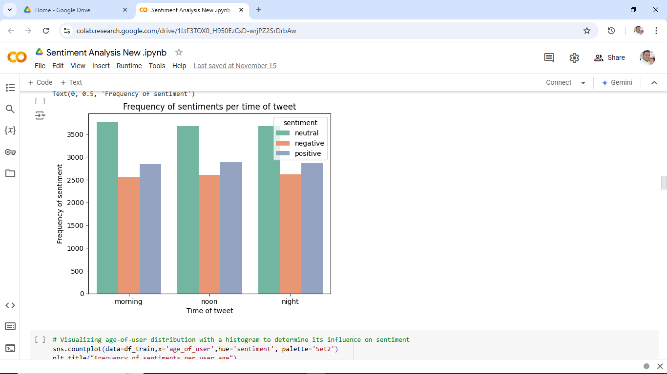

**Figure 4.2.3 Data Processing Result**

   

## .Result Of Concentration Analysis:

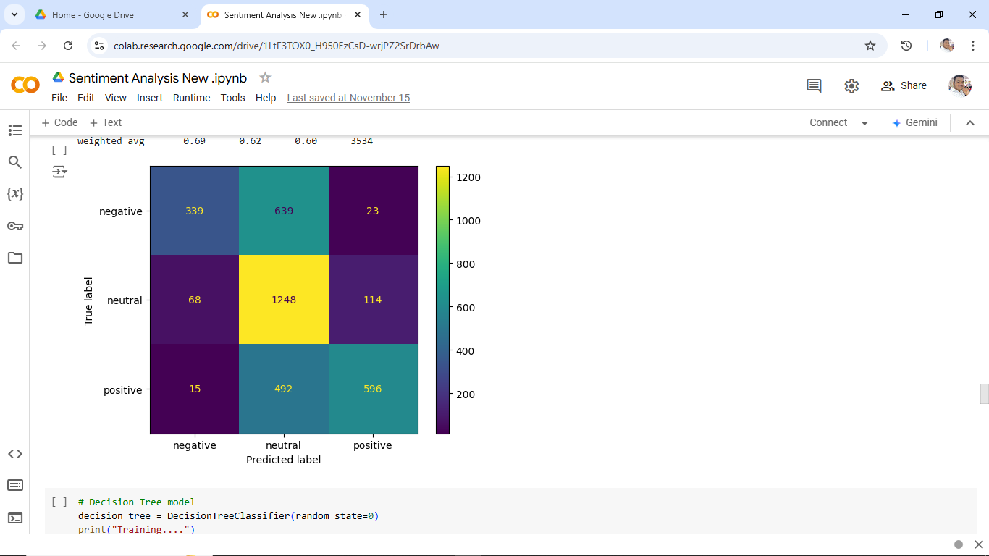

**Figure 4.3.1 Positive and Negative Sentiment Analysis**

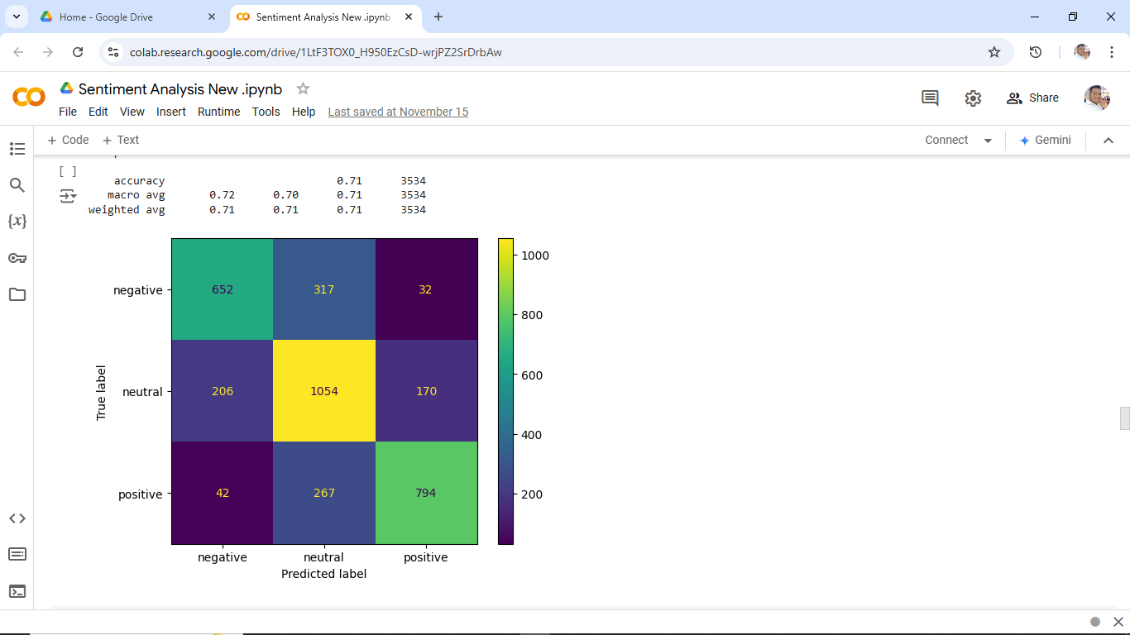

**Figure 4.3.2 Sentiment Analysis**

   

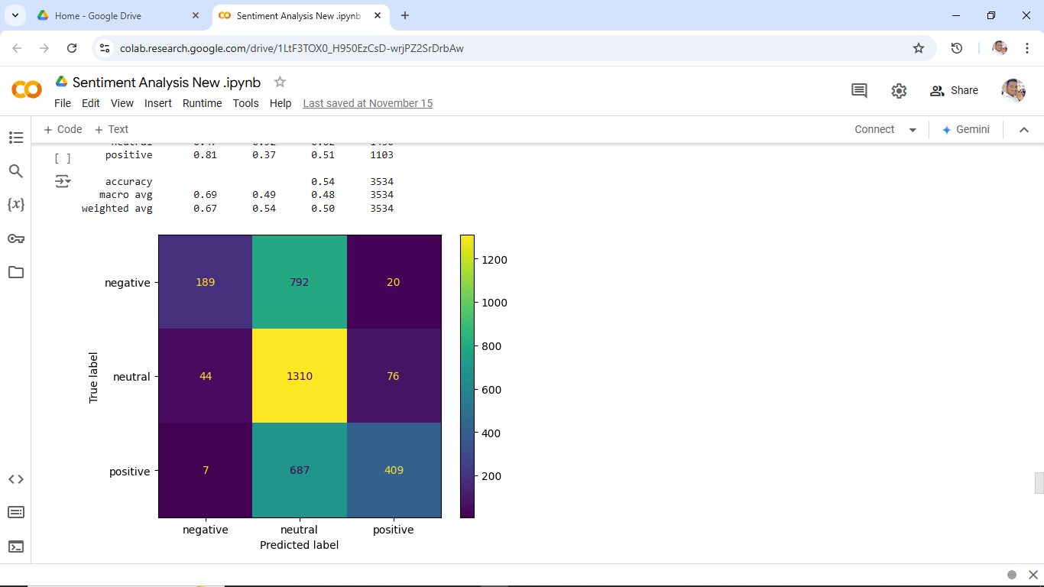

## Figure 4.3.3 Create bag of words

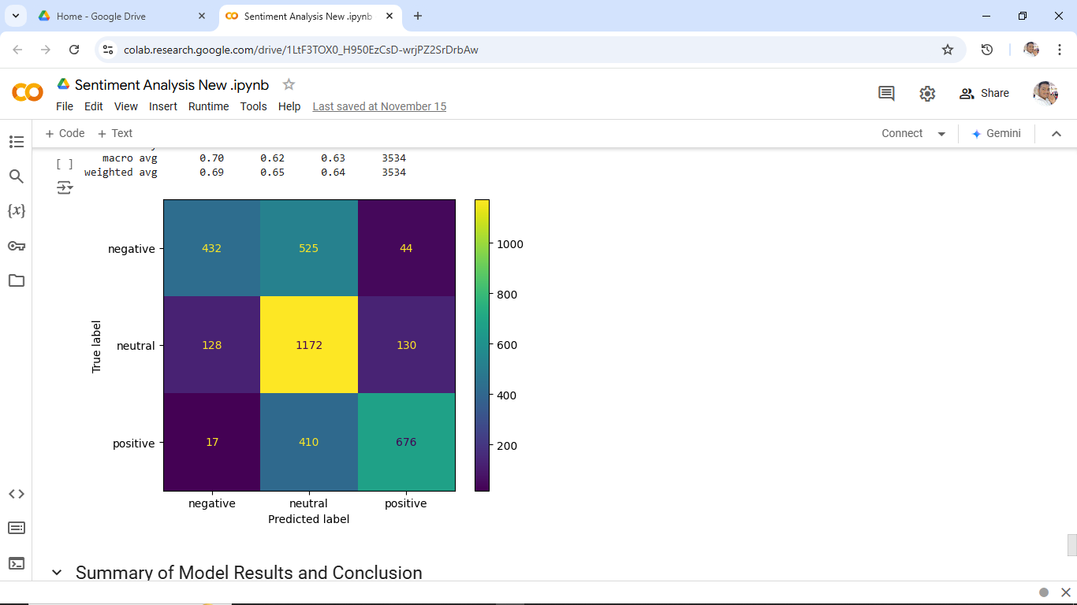

**Figure 4.3.4 Biderectional LSTM Using NN**

   

# CHAPTER 5

## Discussion and Conclusion

## GitHub Link of the Project:

Share the GitHub link <https://github.com/ranjith0019/ranjith20>

## Video Recording of Project Demonstration:

## <https://drive.google.com/file/d/13vNnQDfBc0KQ3koaSJ0KcaaB7tlWFH6a/view>

## 5.3.Limitations:

## 5.3.1.Contextual Understanding and Nuance:

**Lack of Deep Context**: Sentiment analysis models often struggle to capture the deeper context or underlying message in a sentence. For example, "The service was slow, but the food was amazing!" expresses both positive and negative sentiments, which may be hard for models to capture accurately.

**Complex Sentence Structures**: Complex structures, such as sarcasm, irony, or idiomatic expressions, can mislead sentiment analysis models, resulting in incorrect classifications. For example, "Oh, great! Another delay!" is sarcastic but could be misinterpreted as positive.

## 5.3.2.Sarcasm and Irony:

**Detection Difficulty**: Sarcasm and irony involve saying the opposite of what is meant, making it difficult for sentiment models to correctly interpret the intended sentiment. For example, "Just what I needed, more work!" could be interpreted as positive when it is, in fact, negative.

**Lack of Tone Cues**: Without vocal intonation or facial expressions, text-based analysis lacks the extra cues that help humans identify sarcasm and irony.

## 5.3.3.Ambiguity and Subjectivity:

**Personal Interpretation Variability**: Words or phrases can mean different things to different people, making sentiment subjective. For example, "cheap" can have a positive connotation (affordable) or a negative one (low quality) depending on the context.

   

**Ambiguity in Language**: Ambiguous statements like "The movie was different" can be hard to classify since the sentiment can vary depending on personal perception.

## 5.3.4.Limited Handling of Mixed Sentiments:

**Difficulty with Dual Sentiments**: Sentences that express both positive and negative sentiments simultaneously are challenging for sentiment analysis models. For instance, in the review, "The product works well, but it’s overpriced," most models will struggle to capture both aspects accurately.

**Failure in Aspect-Based Sentiment Analysis**: Often, sentiment analysis is generalized and doesn’t provide insights into specific aspects of the text. If a review says, "The battery life is great, but the screen is too dim," a generalized model may classify this as either positive or negative overall, without distinguishing between aspects.

## 5.3.5.Cultural and Linguistic Variability:

**Cultural Differences**: Sentiment interpretation can vary significantly across cultures. For example, a phrase seen as neutral in one culture might be positive or negative in another, making it difficult for models trained on one dataset to generalize well across diverse populations.

**Linguistic Variability**: Language evolves constantly, with new slang, idioms, and expressions emerging regularly. Sentiment analysis models trained on older datasets may fail to interpret newer expressions or cultural references correctly.

## 5.4.Future Work:

## 5.4.1.Improved Contextual Understanding:

**Context-Aware Models**: Building models that can capture the deeper meaning of words and phrases in context, considering previous sentences and the overall document sentiment.

**Fine-Tuning for Nuance**: Developing models that recognize subtle distinctions in language, such as degrees of positivity or negativity and more accurate handling of phrases with dual sentiments (e.g., “The food was great, but service was terrible”).

## 5.4.2.Sarcasm and Irony Detection:

**Advanced NLP Techniques**: Applying deep learning models that are trained to detect sarcasm and irony by identifying patterns commonly associated with these linguistic forms.

   

**Multimodal Analysis**: Combining textual analysis with tone, sentiment context, and potentially visual data (such as emojis in social media) to improve the recognition of sarcasm.

## 5.4.3.Aspect-Based Sentiment Analysis (ABSA):

**Fine-Grained Sentiment Detection**: Focusing on aspect-based sentiment analysis, which identifies sentiments related to specific aspects or features of a product, service, or entity (e.g., in a product review, distinguishing sentiment toward quality, price, and durability).

**Contextual Aspect-Specific Datasets**: Creating more refined and diverse datasets specifically for ABSA, helping models understand how sentiment can vary across different aspects within a single review.

## 5.4.4.Cross-Domain and Transfer Learning:

**Domain Adaptability**: Using transfer learning to train models that generalize well across different domains, such as product reviews, social media, and customer feedback, reducing the need for domain-specific training.

**Few-Shot and Zero-Shot Learning**: Leveraging few-shot or zero-shot learning to allow sentiment models to quickly adapt to new domains or languages with minimal data, enabling broader application across industries and regions.

## 5.4.5.Multilingual and Cross-Cultural Sentiment Analysis:

**Improved Multilingual Models**: Expanding multilingual capabilities to allow sentiment analysis to work accurately across many languages and dialects, utilizing multilingual transformers and cross-lingual embeddings.

**Culturally Sensitive Sentiment Analysis**: Accounting for cultural differences in sentiment expression, such as cultural-specific phrases, idioms, and connotations, to improve the accuracy of sentiment classification across diverse populations.

## 5.4.6.Emotion Recognition and Sentiment Granularity:

**Emotion-Specific Analysis**: Moving beyond basic positive/negative/neutral classification to detect more nuanced emotions like joy, sadness, anger, surprise, and disgust. Models that capture a range of emotions provide richer insights, especially for applications in customer feedback and mental health.

   

**Multi-Dimensional Sentiment Analysis**: Exploring multi-dimensional analysis, where sentiment is assessed on several dimensions (such as intensity, arousal, and valence) to provide a more detailed sentiment profile.

## 5.5.Conclusion:

In conclusion, sentiment analysis has proven to be a powerful tool for understanding human emotions, opinions, and trends in textual data across various domains, including customer feedback, social media monitoring, and market research. While it enables businesses and researchers to quickly interpret vast amounts of data, it faces several challenges such as accurately interpreting context, sarcasm, and cultural differences.

Future developments in natural language processing, machine learning, and data representation hold promise for addressing these limitations, making sentiment analysis more nuanced, adaptive, and contextually aware.

   

## REFERENCES

1. Caruana, R., et al. (2015). Intelligible Models for Healthcare: Predicting Pneumonia Risk and Hospital 30-Day Readmission.
2. McGlynn, E. A., et al. (2020). Telemedicine applications in healthcare: Streamlining AI-based symptom checkers.
3. Miotto, R., et al. (2016). Deep learning for healthcare: Review of applications and research opportunities.
4. Kourou, K., et al. (2015). Machine learning applications in cancer prognosis and outcome prediction.